WebSphere Appliation Sever Migration

V6.1.0.29 ~ V7.0.0.25
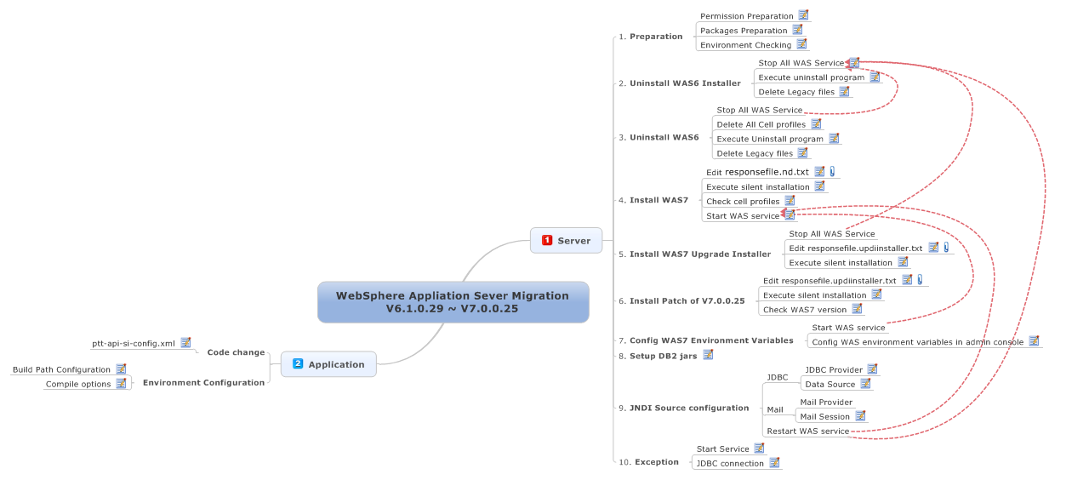

WebSphere Appliation Sever Migration V6.1.0.29 ~ V7.0.0.25 1
1 Server 2
1.1 Preparation 2
1.1.1 Permission Preparation 2
1.1.2 Packages Preparation 2
1.1.3 Environment Checking 3
1.2 Uninstall WAS6 Installer 4
1.2.1 Stop All WAS Service 4
1.2.2 Execute uninstall program 5
1.2.3 Delete Legacy files 5
1.3 Uninstall WAS6 5
1.3.1 Delete All Cell profiles 5
1.3.2 Execute Uninstall program 6
1.3.3 Delete Legacy files 6
1.4 Install WAS7 6
1.4.1 Edit responsefile.nd.txt 6
1.4.2 Execute silent installation 7
1.4.3 Check cell profiles 8
1.4.4 Start WAS service 8
1.5 Install WAS7 Upgrade Installer 9
1.5.1 Edit responsefile.updiinstaller.txt 9
1.5.2 Execute silent installation 10
1.6 Install Patch of V7.0.0.25 11
1.6.1 Edit responsefile.updiinstaller.txt 11
1.6.2 Execute silent installation 11
1.6.3 Check WAS7 version 12
1.7 Config WAS7 Environment Variables 13
1.7.1 Config WAS environment variables in admin console 13
1.8 Setup DB2 jars 13
1.9 JNDI Source configuration 13
1.9.1 JDBC 13
JDBC Provider 13
Data Source 17
1.9.2 Mail 25
Mail Session 25
1.10 Exception 27
1.10.1 Start Service 27
1.10.2 JDBC connection 28
2 Application 29
2.1 Code change 29
2.1.1 ptt-api-si-config.xml 29
2.2 Environment Configuration 30
2.2.1 Build Path Configuration 30
2.2.2 Compile options 32

- Server
  - Preparation
    - Permission Preparation
1. login as root user
    - Packages Preparation
1.For WAS7 Installation:
C1G35ML.tar.gz -- WAS7 base installation package.
C1G36ML.tar.gz -- WAS7 upgrade installer package.
7.0.0-WS-WAS-LinuxX64-FP0000025.pak -- patch of V7.0.0.25

2.For DB2 drive jar:

- copy all WAS7 installation packages to /opt/ibm/WAS7_64
- create directories in /opt/ibm/WAS7_64 to contain unziped files.
[root@wastest WAS7_64]# mkdir C1G35ML
[root@wastest WAS7_64]# mkdir C1G36ML
- unzip each zip files
[root@wastest WAS7_64]# tar -zxvf C1G35ML.tar.gz -C C1G35ML
[root@wastest WAS7_64]# tar -zxvf C1G36ML.tar.gz -C C1G36ML

    - Environment Checking
1.check host name:
(1)[root@wastest lishuai]# cat /etc/hosts
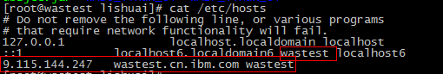
(2)[root@wastest lishuai]# cat /etc/sysconfig/network
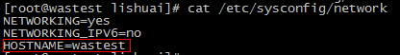
(3)[root@wastest lishuai]# hostname
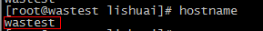
all the hostname must be the same and link to the same full domain name

  - Uninstall WAS6 Installer
    - Stop All WAS Service
1.check WAS6 running status
[root@wastest /]# ps -ef |grep java
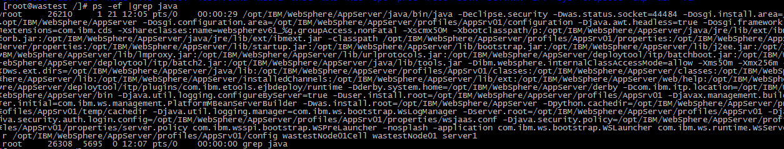

2.stop service
[root@wastest /]# cd /opt/IBM/WebSphere/AppServer/profiles/AppSrv01/bin/
[root@wastest bin]# ./stopServer.sh server1
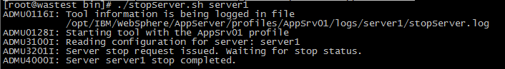

3.check whether WAS service is stoped again.
[root@wastest /]# ps -ef |grep java
we can continue to next step when make sure WAS service stoped completely.
    - Execute uninstall program
[root@wastest uninstall]# cd /opt/IBM/WebSphere/UpdateInstaller/uninstall
[root@wastest uninstall]# ./uninstall

ps:
we can ignore "./uninstall: line 401: [: -ge: unary operator expected",and it does not make any nagative infulence in most of time.
but for some special time,we can fix this warning:
we can replace "if [ $version -ge 5 ]" with "if [[ $version -ge 5 ]]" in line 401 of the file.

    - Delete Legacy files

[root@wastest WebSphere]# rm -rf /opt/IBM/WebSphere/UpdateInstaller/
  - Uninstall WAS6
    - Delete All Cell profiles
[root@wastest bin]# cd /opt/IBM/WebSphere/AppServer/bin
[root@wastest bin]# ./manageprofiles.sh -delete -profileName AppSrv01

    - Execute Uninstall program
[root@wastest uninstall]# cd /opt/IBM/WebSphere/AppServer/uninstall
[root@wastest uninstall]# ./uninstall
    - Delete Legacy files

[root@wastest WebSphere]# rm -rf /opt/IBM/WebSphere/AppServer/
  - Install WAS7
    - Edit responsefile.nd.txt
See attachment(s): responsefile.nd.txt
1.go to WAS7 installation source folder
[root@wastest WAS]# cd /opt/ibm/WAS7_64/C1G35ML/WAS

2.edit responsefile.nd.txt file
[root@wastest WAS]# vim responsefile.nd.txt
make it as follow:
-OPT silentInstallLicenseAcceptance="true"
-OPT allowNonRootSilentInstall="true"
-OPT disableOSPrereqChecking="true"
-OPT checkFilePermissions="true"
-OPT installType="installNew"
-OPT profileType="standAlone"
-OPT feature="noFeature"
-OPT PROF_enableAdminSecurity="true"
-OPT PROF_adminUserName="admin"
-OPT PROF_adminPassword="admin"
-OPT installLocation="/opt/IBM/WebSphere/AppServer"
-OPT PROF_hostName="wastest.cn.ibm.com"

then save.

ps. the immunilated marked parameter is very important,it must be the full domain name and the same with the configuration in /etc/hosts

    - Execute silent installation
1.go to WAS7 installation source folder
[root@wastest WAS]# cd /opt/ibm/WAS7_64/C1G35ML/WAS

2.execute silent installation
[root@wastest WAS]# ./install -options "responsefile.nd.txt" -silent

3.check installation
[root@wastest AppServer]# cd /opt/IBM/WebSphere/AppServer
[root@wastest AppServer]# ls
make sure all the files are created.

ps:
we can ignore "./uninstall: line 401: [: -ge: unary operator expected",and it does not make any nagative infulence in most of time.
but for some special time,we can fix this warning:
we can replace "if [ $version -ge 5 ]" with "if [[ $version -ge 5 ]]" in line 401 of the file.

    - Check cell profiles
go to cell folders
[root@wastest AppSrv01]# cd /opt/IBM/WebSphere/AppServer/profiles/AppSrv01
[root@wastest AppSrv01]# ls

check all the files were created.

if "profiles/AppSrv01" not created. then
[root@wastest AppSrv01]# /opt/IBM/WebSphere/AppServer/bin
[root@wastest AppSrv01]# ./manageprofiles.sh -create -templatePath /opt/IBM/WebSphere/AppServer/profileTemplates/default -profileName AppSrv01

we can continue when make sure the cell files were created.

    - Start WAS service
[root@wastest AppSrv01]# cd /opt/IBM/WebSphere/AppServer/profiles/AppSrv01/bin
[root@wastest bin]# ./startServer.sh server1

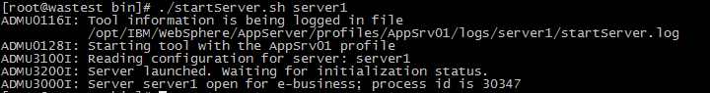
if console shows as above. the service started successfully.

start a broswer go to link https://ip:9043/ibm/console and login with admin/admin

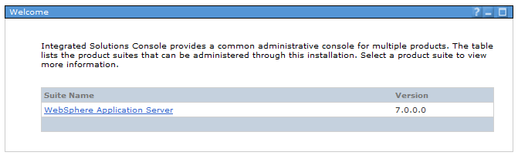

Installation of WAS7.0 was successful if we could log in.
  - Install WAS7 Upgrade Installer
    - Edit responsefile.updiinstaller.txt
See attachment(s): responsefile.updiinstaller.txt
1.go to WAS7 Installer installation source folder
[root@wastest WAS]# cd /opt/ibm/WAS7_64/C1G36ML/UpdateInstaller
[root@pttlocal UpdateInstaller]# vim responsefile.updiinstaller.txt

edit "responsefile.updiinstaller.txt" make it as follow

-OPT silentInstallLicenseAcceptance="true"
-OPT allowNonRootSilentInstall="true"
-OPT disableOSPrereqChecking="true"
-OPT installLocation="/opt/IBM/WebSphere/UpdateInstaller"
-OPT skipStartMenu=true

then save.

    - Execute silent installation
1.go to WAS7 installation source folder
[root@wastest WAS]# /opt/ibm/WAS7_64/C1G36ML/UpdateInstaller

2.execute silent installation
[root@wastest UpdateInstaller]# ./install -options "responsefile.updiinstaller.txt" -silent

3.check installation
[root@wastest UpdateInstaller]# cd /opt/IBM/WebSphere/UpdateInstaller
[root@wastest UpdateInstaller]# ls
make sure all the files are created.

ps:
we can ignore "./uninstall: line 401: [: -ge: unary operator expected",and it does not make any nagative infulence in most of time.
but for some special time,we can fix this warning:
we can replace "if [ $version -ge 5 ]" with "if [[ $version -ge 5 ]]" in line 401 of the file.

  - Install Patch of V7.0.0.25
    - Edit responsefile.updiinstaller.txt
See attachment(s): install.txt
1.go to WAS7 Installer installation source folder
[root@wastest UpdateInstaller]# cd /opt/IBM/WebSphere/UpdateInstaller
[root@wastest UpdateInstaller]# vim responsefiles/install.txt

edit "responsefiles/install.txt" make it as follow

-OPT checkFilePermissions="true"
-W maintenance.package="/opt/ibm/WAS7_64/7.0.0-WS-WAS-LinuxX64-FP0000025.pak"
-OPT rootUserHasRunSlibcleanCommandSuccessfully="true"
-W product.location="/opt/IBM/WebSphere/AppServer"
-W update.type="install"

then save.

    - Execute silent installation
1.go to WAS7 UpdateInstaller folder
[root@wastest UpdateInstaller]# cd /opt/IBM/WebSphere/UpdateInstaller

2.execute silent installation
[root@wastest UpdateInstaller]# ./update.sh -options "responsefiles/install.txt" -silent

    - Check WAS7 version
execute versionInfo.sh
[root@wastest bin]# /opt/IBM/WebSphere/AppServer/bin/versionInfo.sh

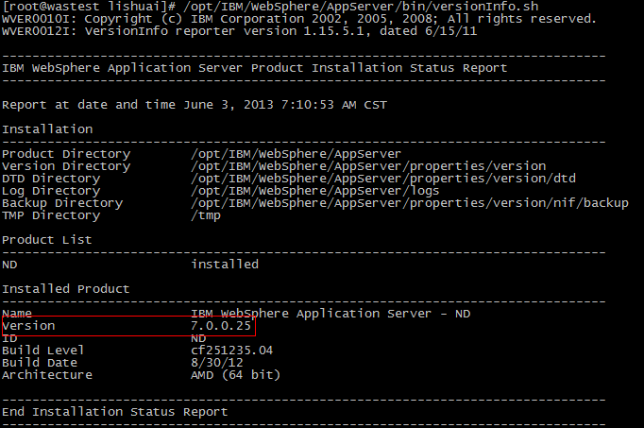

  - Config WAS7 Environment Variables
    - Config WAS environment variables in admin console
1 login in https://ip:9043/ibm/console with username and password.
2 click Environment->Websphere variables
3 set the parameters as follow:
Name | Value
DB2UNIVERSAL_JDBC_DRIVER_NATIVEPATH: | ${WAS_INSTALL_ROOT}/universalDriver/lib
DB2UNIVERSAL_JDBC_DRIVER_PATH: | ${WAS_INSTALL_ROOT}/universalDriver/lib
DB2_JCC_DRIVER_NATIVEPATH: | ${WAS_INSTALL_ROOT}/universalDriver/lib
DB2_JCC_DRIVER_PATH: | ${WAS_INSTALL_ROOT}/universalDriver/lib

  - Setup DB2 jars
copy db2jcc.jar to /opt/IBM/WebSphere/AppServer/universalDriver/lib

[root@wastest lib]# cp db2jcc.jar /opt/IBM/WebSphere/AppServer/universalDriver/lib/

  - JNDI Source configuration
    - JDBC
JDBC Provider
1.click Resources->JDBC->JDBC providers
2.chose node1 in scope selection.
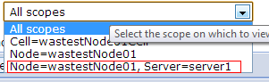
3.click "New" button.
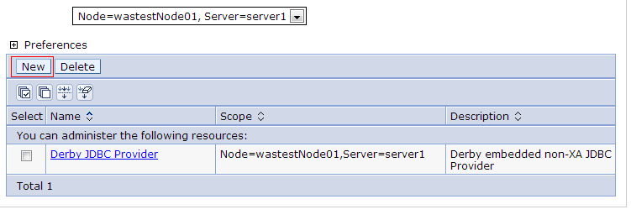
4.set parameters as follow
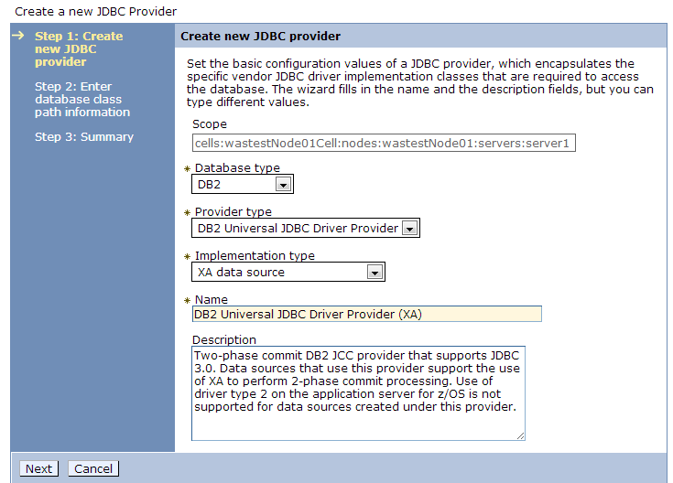
then click next.
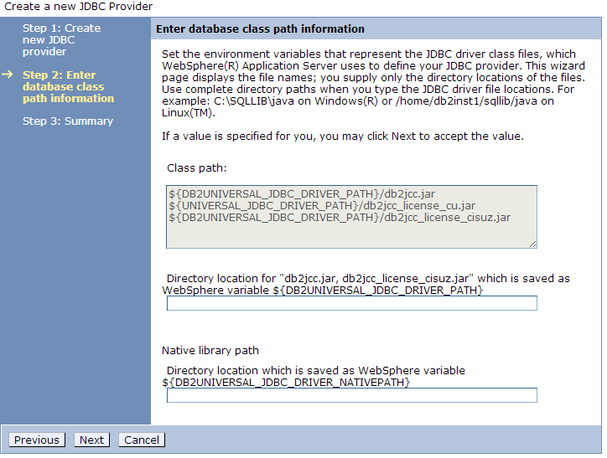
click next.
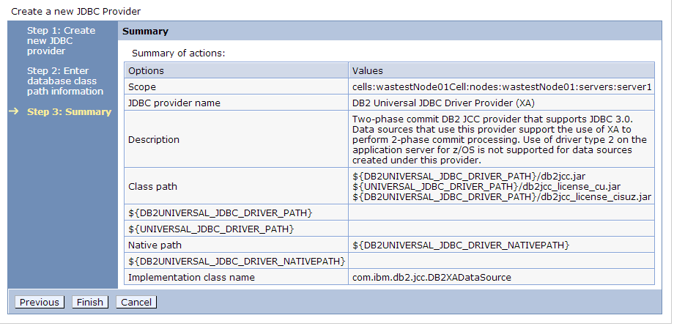
click Finish. save jdbc Provider changes.

Data Source
1. click Resources->JDBC->Data sources
2. chose node in scope selection.
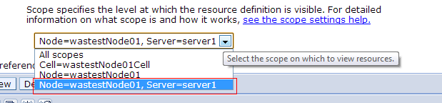
3. click "New" button.
4. set parameters as screenshots
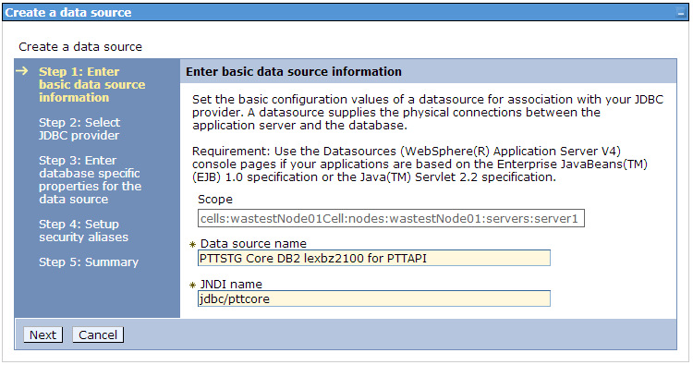
click next.
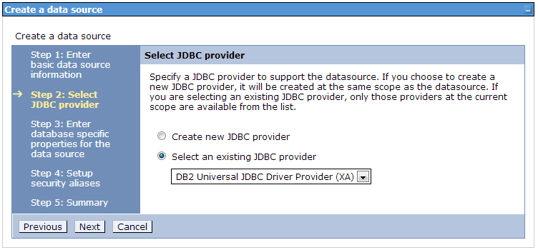
click next.
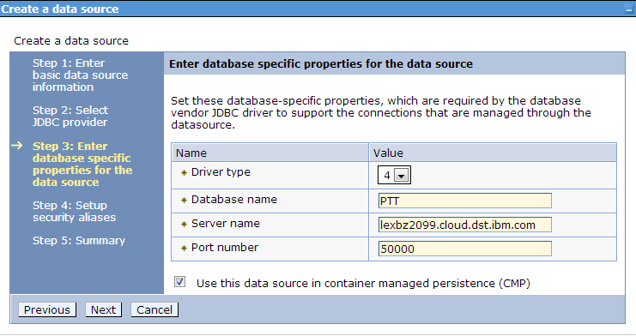
click next.
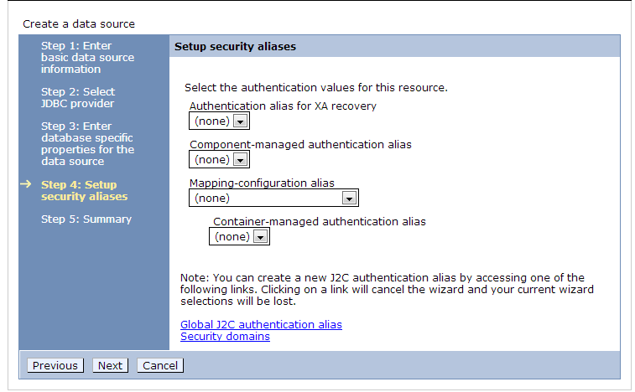
click next.
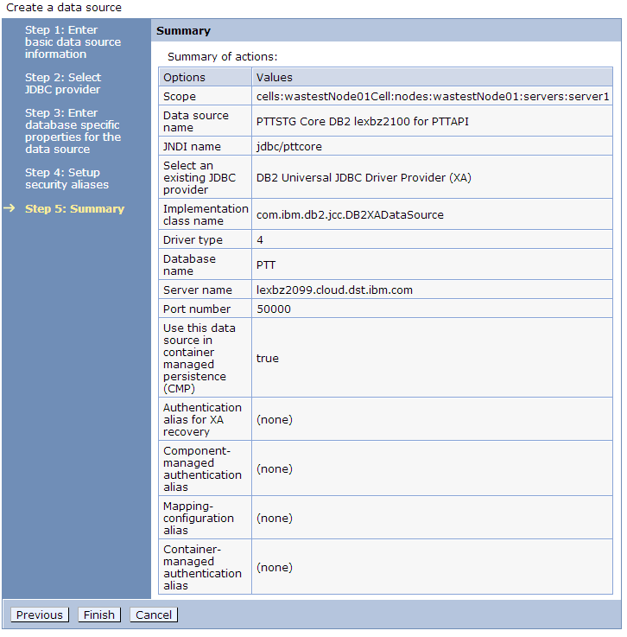
click finish. save changes.
5.
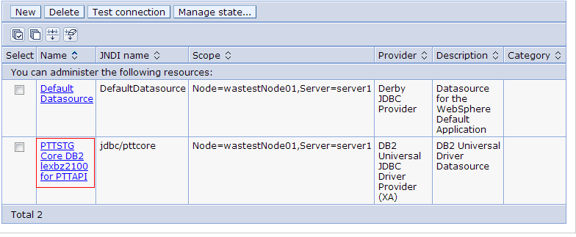
click data source linke which was just created in last step.
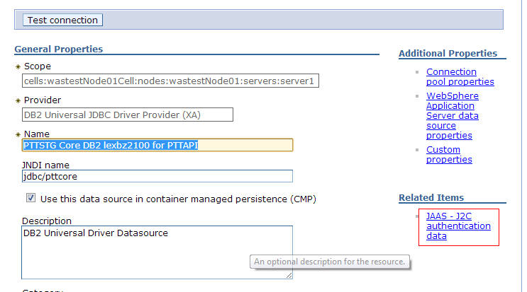
click "JAAS-J2C authentication data".
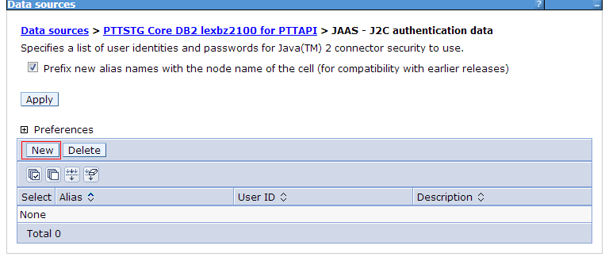
click "New" button.
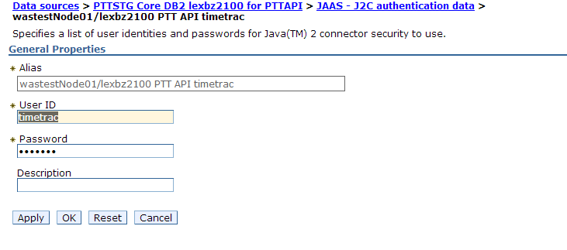
click "OK", save changes. then back to data sources page.
click data source link.
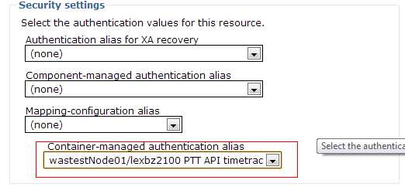
chose right authentication. save changes.
then back to data sources page again.
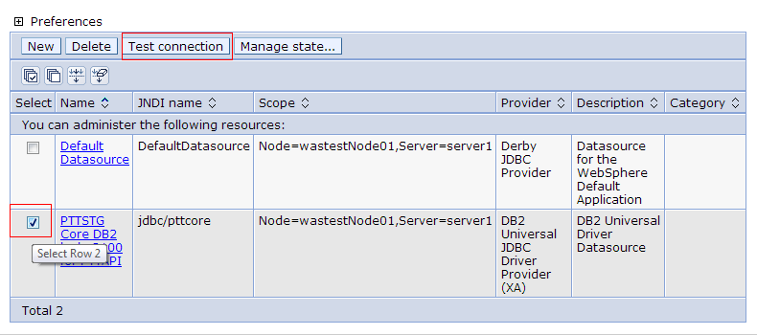
select datasource and click "Test connection" button.
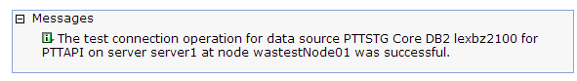
if message jumped as above, it means our datasource configuration is successful.

follow as all above configure all the datasources one by one and make sure each tested successfully.

    - Mail
Mail Session
1.click Resources->Mail->Mail sessions
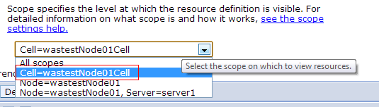
select cell in scope selection

2. click "New" button
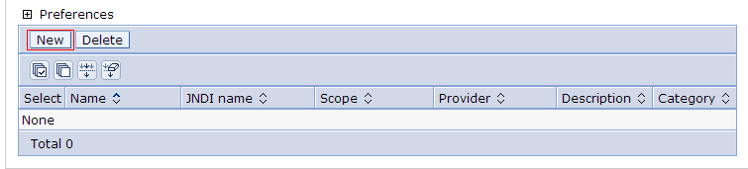

3. set parameters as follow screenshot.
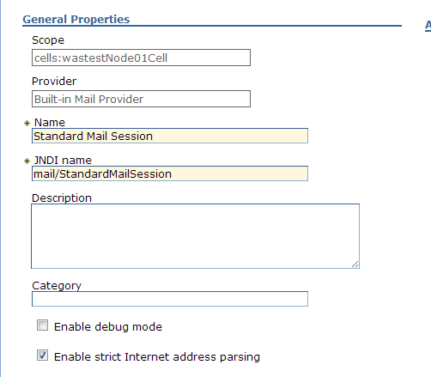
then save changes.

  - Exception
    - Start Service
*Server starting log location: /opt/IBM/WebSphere/AppServer/profiles/AppSrv01/logs/server1/startServer.log
1. 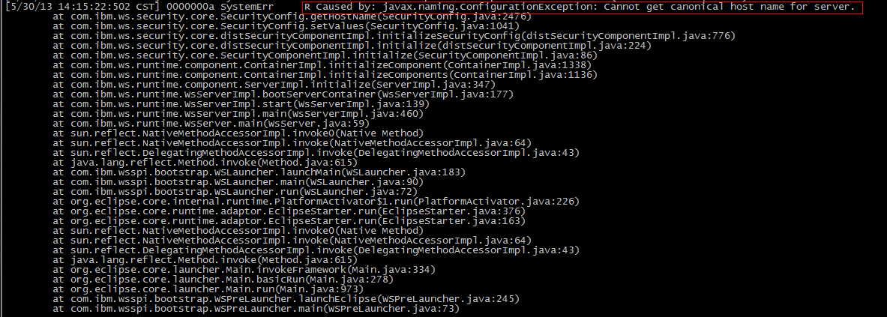
check host name in preparation step, change host name,restart restart service,if not works, reboot the system try again.
    - JDBC connection
*Server Error log location: /opt/IBM/WebSphere/AppServer/profiles/AppSrv01/logs/server1/SystemErr.log

1.
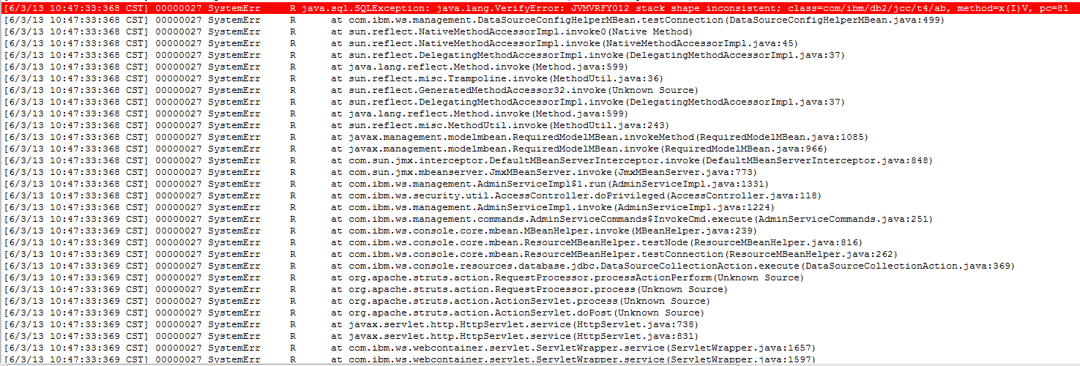
restart WAS service.
- Application
  - Code change
    - ptt-api-si-config.xml
Add <beans:property name="resourceRef" value="true"/> in the follow place

<!-- Set up the data source for the PTT Core database -->
<beans:bean id="dataSourcePttCore" class="org.springframework.jndi.JndiObjectFactoryBean">
<beans:property name="jndiName" value="${data.source.pttcore}"/>
<beans:property name="resourceRef" value="true"/>
</beans:bean>

<!-- Set up the data source for the PTT Resource Manager database -->
<beans:bean id="dataSourcePttResMn" class="org.springframework.jndi.JndiObjectFactoryBean">
<beans:property name="jndiName" value="${data.source.pttresmn}"/>
<beans:property name="resourceRef" value="true"/>
</beans:bean>
  - Environment Configuration
    - Build Path Configuration
1.click project in workplace on right button, chose properties
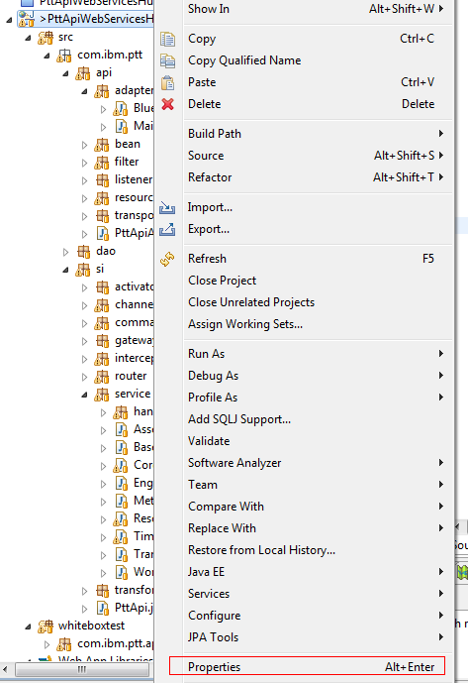
2. click "Java Build Path"
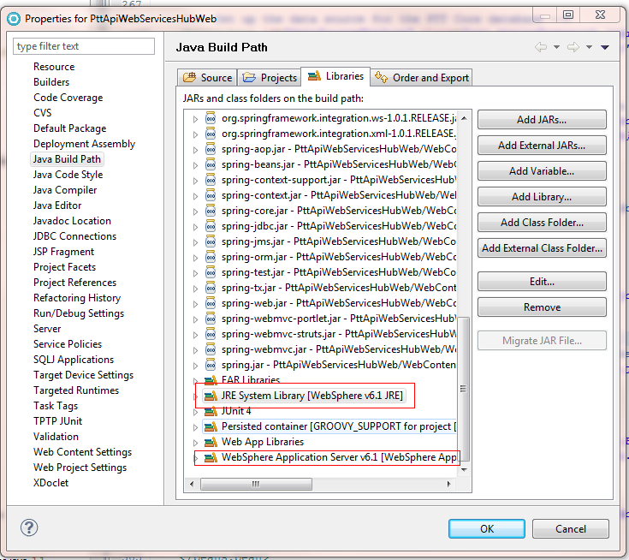
eidt "JRE System Library" and "WebSphere Application Server V6.1" and transfer both to WAS7's.

    - Compile options
1.click project in workplace on right button, chose properties
2.click "Java Compiler" option.
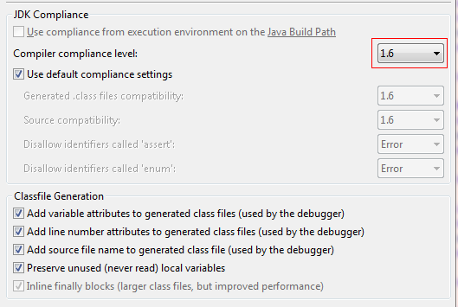
change "Compiler compliance level" to "1.6"

